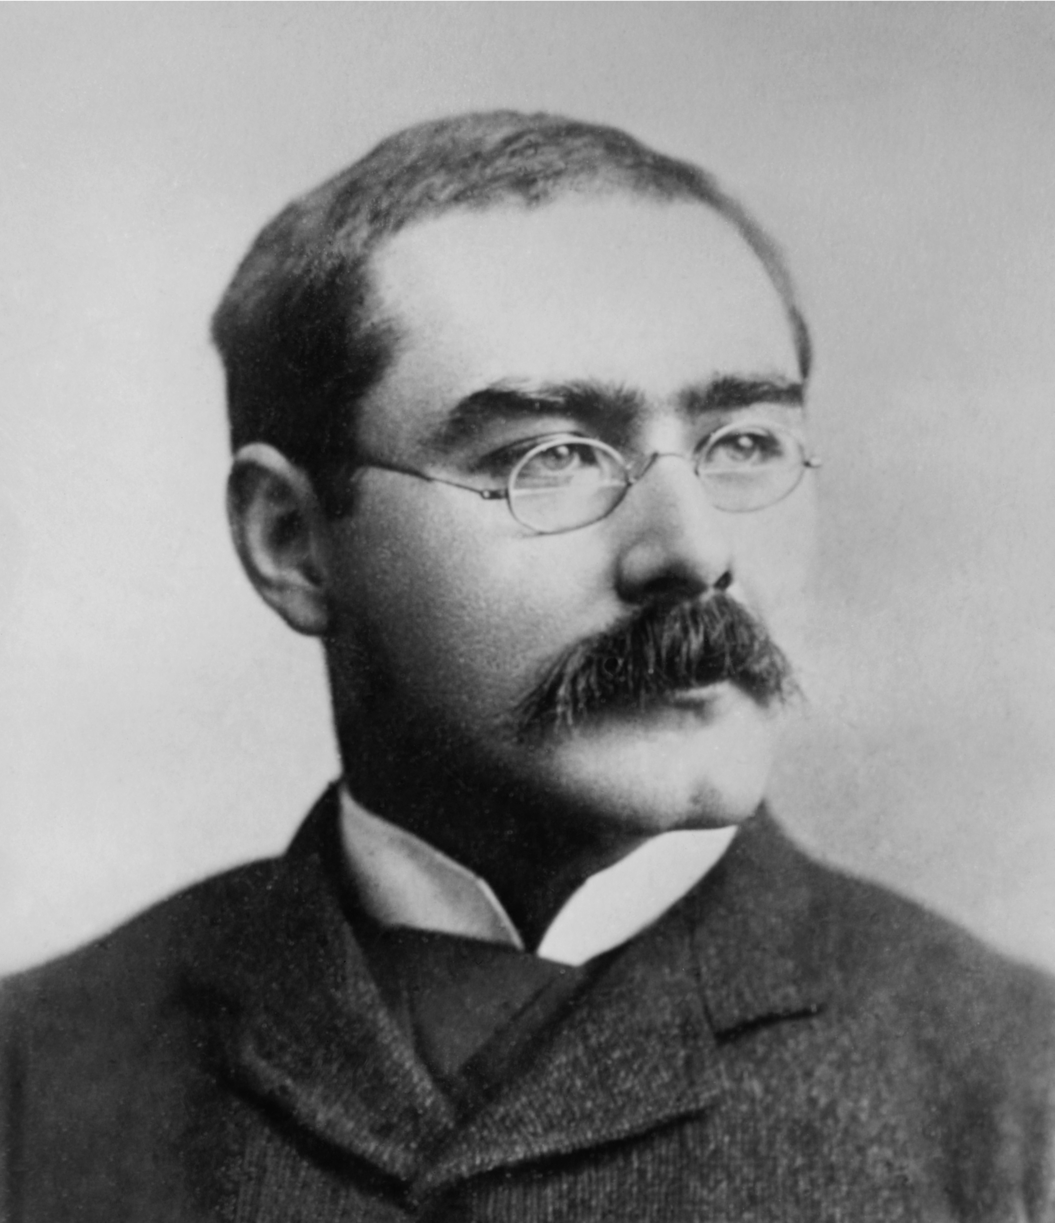**'If -' by Rudyard Kipling**

**6 word summary: father teaches son to be man**

**A**

**A**

**A**

**A**

**B**

**C**

**B**

**C**

**If** you can keep your head when all about you

    Are losing theirs and blaming it on you,

**If** you can trust yourself when all men doubt you,

    But make allowance for their doubting too;

**If** you can wait and not be tired by waiting,

    Or being lied about, **don’t deal** in lies,

Or being hated**, don’t give** way to hating,

    And yet **don’t look** too good, nor talk too wise:

**A**

**B**

**A**

**B**

**C**

**D**

**C**

**D**

If you can dream—and not make dreams your master;

    If you can think—and not make thoughts your aim;

If you can meet with Triumph and Disaster

    And treat those two impostors just the same;

If you can bear to hear the truth you’ve spoken

    Twisted by knaves to make a trap for fools,

Or watch the things you gave your life to, broken,

    And stoop and build ’em up with worn-out tools:

**A**

**B**

**A**

**B**

**C**

**D**

**C**

**D**

If you can make one heap of all your winnings

    And risk it on one turn of pitch-and-toss,

And lose, and start again at your beginnings

    And never breathe a word about your loss;

If you can force your heart and nerve and sinew

    To serve your turn long after they are gone,

And so hold on when there is nothing in you

    Except the Will which says to them: ‘Hold on!’

**A**

**B**

**A**

**B**

**C**

**D**

**C**

**D**

If you can talk with crowds and keep your virtue,

    Or walk with Kings—nor lose the common touch,

If neither foes nor loving friends can hurt you,

    If all men count with you, but none too much;

If you can fill the unforgiving minute

    With sixty seconds’ worth of distance run,

Yours is the Earth and everything that’s in it,

    And—which is more—you’ll be a Man, my son!

**Rudyard Kipling**

* He was born in Bombay, British India, in 1865 and was educated in Britain from the age of 5, which was normal for the children of British servicemen working in India.
* He wrote tales and poems of British soldiers in India and stories for children. Kipling was perhaps one of the most popular writers in England, in both prose and verse in the late 19th and early 20th centuries and was awarded the Nobel Prize in Literature in 1907. At this time, the British Empire was at its **zenith** (height). Kipling is often viewed as a controversial but an essential “interpreter of how empire was experienced”.

**Kipling and 'If'**

* The poem was written in 1895 and published in 1910 edition of *Rewards and Fairies*
* The poem is a tribute to Leander Starr Jameson (a British colonial politician) and is written in the form of **paternal** **advice** to the poet's son.
* The poem is an example of **Victorian-era stoicism**; this is the idea of having a “stiff upper lip” (**idiom**), basically displaying courage in the face of **adversity** (hardship)

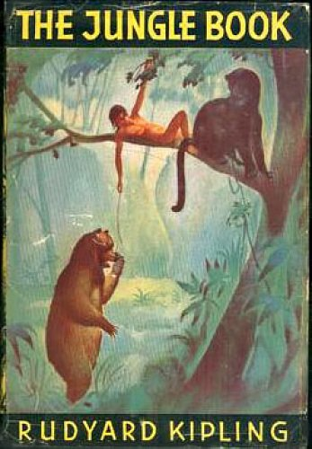

If you can keep your head when all about you

    Are losing theirs and blaming it on you,

If you can trust yourself when all men doubt you,

    But make allowance for their doubting too;

If you can wait and not be tired by waiting,

    Or being lied about, don’t deal in lies,

Or being hated, don’t give way to hating,

    And yet don’t look too good, nor talk too wise:

If you can dream—and not make dreams your master;

    If you can think—and not make thoughts your aim;  (polyptoton: same root but different spelling)

If you can meet with Triumph and Disaster

    And treat those two impostors just the same;

****If you can bear to hear the truth you’ve spoken

    Twisted by knaves to make a trap for fools,

Or watch the things you gave your life to, broken,

    And stoop and build ’em up with worn-out tools:

If you can make one heap of all your winnings

    And risk it on one turn of pitch-and-toss,

And lose, and start again at your beginnings

    And never breathe a word about your loss;

If you can force your heart and nerve and sinew

    To serve your turn long after they are gone,

And so hold on when there is nothing in you

    Except the Will which says to them: ‘Hold on!’

If you can talk with crowds and keep your virtue,

    Or walk with Kings—nor lose the common touch,

If neither foes nor loving friends can hurt you,

    If all men count with you, but none too much;

If you can fill the unforgiving minute

    With sixty seconds’ worth of distance run,

Yours is the Earth and everything that’s in it,

    And—which is more—you’ll be a Man, my son!

Theme: 1. Composure and self-restrain; 2. Masculinity

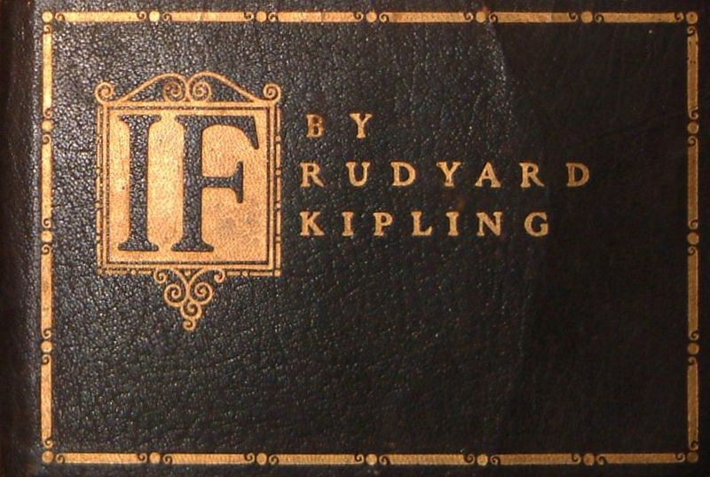

**What's up with the title?**

“If” usually describes something that isn't real, or isn't real *yet,* it points to something that could potentially happen/exist …“**if** you go to the shop you can get some chocolate”, “**if** you lose my dress, you’re dead”. This poem is all about the things the persona hasn’t done yet, he hasn’t learnt to be strong, wise or patient but *If* he does them, but only *if*, then he will basically have possession of the entire world and what’s more, that’s when he will become a man.

**Links to other poems:**

Father>son conversations: *Once Upon a Time*

Conversations about fears/hopes & dreams: *Prayer Before Birth*

Conversation: *Telephone Conversation, Remember*

**Structure and Form:**

Written in four **octaves** (8 line stanzas)

**Rhythm**:

All the **even** stanzas (2,4,6,8 etc) are written in **iambic pentameter** e.g. **Are LO-sing THEIRS and BLA-ming IT on YOU, -** it had the **unstressed**, **STRESSED** pattern.

HOWEVER, the **odd** stanzas (1,3,5 etc) are different. Although they too are written in **iambic pentameter** e.g. **If YOU can KEEP your HEAD when ALL a BOUT you >** there is an **extra syllable,** this is called **hypermeter.**

**WHY I HEAR YOU CRY**? In a poem all about life and consequences, Kipling’s alternate use of regular **iambic pentameter** and **hypermeter** reflects the unpredictably of life itself.

**Rhyme**

This idea of **unpredictability** is strengthened by the poem’s rhyme scheme…Kipling was quite the poet! This poem has an **irregular rhyme scheme.**

As you can see, the first octave has a different rhyme scheme to the rest of the poem. In a poem that is so carefully balanced, this first stanza sticks out like a sore thumb and that is precisely why it's been done. The poem is all about the uncertainty of life, it is all about life throwing curve balls at you thus this first stanza becomes **the poetic embodiment** of such a curveball; it's the poem's way of displaying one of the poem's major themes; life's unpredictability.

**BUT WHY, WHEN THE POEM HAS AN IRREGULAR RHYTHM DOES KIPLING NEED AN IRREGULAR RHYME SCHEME?**

By using an alternate rhyme **and** an alternate metre, Kipling highlights the importance of pairs, of twos, of sequences. In a poem all about consequences, (if you do x you will achieve y) this is a very important set up. Essentially, Kipling expresses the very essence of the poem through the poem's very rhyme and meter.

**WHAT'S UP WITH ALL THE REPETITION? IF IF IF AND AND AND...**

Throughout the poem, Kipling’s persona uses **repetition,** frequently beginning his sentences with “If” or “And”. This use of **anaphora** reflects the lecture-type speech being delivered from this father to his son. The use of simple, repeated language works well with children who require constant reminding in order to absorb ideas and information. Whilst the use of anaphora may appear tedious to the adult ear, when delivering a speech on how to conquer the world to a young person, **anaphora** is an effective strategy. Moreover, the constant **repetition** of "and" creates a list like effect, a constant adding-on of ideas or information thus reflecting the overflow of advice this father wishes to pass on to his son.

**SO ENJAMBMENT....?**

The frequent use of enjambment reflects the constant flow advice of the father. Moreover, this flow gives the poem a natural rhythm, very much like everyday speech, which heightens the authenticity of the conversation.



**Key Vocabulary**

**Octave**: an eight line stanza

**Enjambment:** the continuation of a sentence without a pause beyond the end of a line, couplet, or stanza.

**Iambic pentameter:** a ten syllable line, consisting of 5 iambic 'couples' of unstressed followed by a stressed syllable e.g. **Are LO-sing THEIRS and BLA-ming IT on YOU** (CAPITALS = **STRESSED** syllable)

**Repetition**: the action of repeating something that has already been said or written.   
**Anaphora:** the repetition of a word or phrase at the beginning of successive clauses.

**Irregular rhyme scheme**: not set rhyme scheme for the entire poem

**Hypermeter:** a verse or line containing additional syllables after those proper to the meter aka extra syllable

**Stoicism:** the endurance of pain or hardship during tough times without the display of feelings and without complaint.